**PROJECT REPORT ON**

**Flutter-Based Grocery App with Razorpay Integration**



REPORT SUBMITTED TO

VISHWAKARMA INSTITUTE OF INFORMATION TECHNOLOGY, PUNE

FOR THE ENGINEERING ECONOMICS and FINTECH

IN

**DEPARTMENT OF COMPUTER ENGINEERING**

**AY 2023-24**

**Semester VI**

BY

**Rajan Sudan - Roll Number 321054 PRN Number 22110156**

**Madhurya Khajuri - Roll Number 321040 PRN Number 22110147**

**Sumedha Sagbhor - Roll Number 321057 PRN Number 22110576**

**Dikshit Sharma - Roll Number 323021 PRN Number 22110148**

**Class: T. Y Guidance by: Mrs. Disha Wankhede**

**Index**

1. Abstract
2. Introduction
3. Methodology
4. Images
5. Future Scope
6. Conclusion
7. References

**Abstract**

The rapid growth of mobile technology has transformed the way consumers interact with businesses, particularly in the realm of grocery shopping. In response to this trend, our project introduces a Flutter-based grocery app with seamless integration of Razorpay payment gateway, aiming to enhance user convenience and streamline the shopping experience.

The app offers a user-friendly interface designed using Flutter, a popular cross-platform framework known for its efficiency and versatility. Users can browse a diverse range of grocery items categorized intuitively, facilitating effortless navigation.

The objectives of developing a Flutter-based grocery app with Razorpay integration are multi-faceted and aim to address various aspects of user experience, business efficiency, and technological advancement like Enhanced User Convenience, Efficient Order Management, Secure Payment Processing and Technological Innovation.

**Introduction**

In today's dynamic marketplace, where time is of the essence and convenience reigns supreme, the realm of grocery shopping is undergoing a profound transformation. With the pervasive influence of mobile technology, consumers increasingly seek streamlined solutions that fit seamlessly into their busy lifestyles. Enter our innovative Flutter-based grocery app, seamlessly integrated with Razorpay, a frontrunner in secure and adaptable payment gateways. The objectives of developing a Flutter-based grocery app with Razorpay integration encompass a range of user-centric and business-oriented goals, aiming to deliver a comprehensive and seamless shopping experience while driving efficiency and growth:

* Enhanced User Convenience: By leveraging Flutter's capabilities for cross-platform development, the app ensures accessibility across various devices and operating systems, enabling users to shop anytime, anywhere.
* Secure Transactions: By integrating Razorpay's robust payment gateway, the app aims to safeguard users' sensitive financial information through encryption, thereby fostering trust and confidence among users.
* Technological Innovation: Leveraging Flutter's capabilities for rapid development and Razorpay's advanced payment solutions represents a commitment to technological innovation. The objective is to stay at the forefront of mobile app development trends, continuously improving and iterating upon the app to meet the evolving needs of users and businesses alike.

The scope of a Flutter-based grocery app with Razorpay integration encompasses various aspects of development, functionality, and user experience, aimed at creating a comprehensive solution that facilitates convenient and secure grocery shopping.

Designing an intuitive and visually appealing user interface that allows for easy navigation and seamless interaction. Ensuring a smooth and efficient user experience throughout the app, from browsing products to completing transactions via Razorpay.

Allowing users to add products to their cart, view cart contents, update quantities, and remove items as needed. Implementing a streamlined checkout process with Razorpay integration, providing multiple payment options and a seamless payment experience.

**Methodology**

The User Interface is designed, keeping in mind the ease for the user. The basic flow of the flutter based grocery app is as flows. On the home page user have to click on get started to go on the grocery items page. The grocery items page shows all the items currently available for buying with it’s price to the User. The User can select which items he/she wants. On My Cart page all the selected items are shown with there quantity and price. At the bottom the total price is shown with the buy now button. By clicking on that button you can pay by various option. ‘Payment successful’ would be shown when the payment is completed.

**Tools and Technologies used :**

**Flutter :**

Flutter is an open-source UI software development kit created by Google. It's used to build natively compiled applications for mobile, web, and desktop from a single codebase. Flutter allows developers to write code once and deploy it across different platforms, which can significantly streamline the development process.One of the key features of Flutter is its use of a programming language called Dart, which was also developed by Google. Dart is known for its simplicity and efficiency, making it well-suited for mobile app development.Flutter uses a reactive framework, which means that changes in the app's state automatically trigger updates to the user interface. This makes it easier for developers to create dynamic and interactive user experiences.Flutter provides a rich set of pre-designed widgets that developers can use to build their app's user interface. These widgets are highly customizable and can be combined in various ways to create complex layouts.

**Razorpay :**

Razorpay is an online payment gateway and payment processing company based in India. It provides businesses with the tools and infrastructure needed to accept online payments from customers. Razorpay offers a wide range of payment options, including credit and debit cards, net banking, UPI (Unified Payments Interface), wallets, and more.Businesses can integrate Razorpay's payment gateway into their websites, mobile apps, or other digital platforms to enable seamless transactions. Razorpay's platform is designed to be developer-friendly, with easy-to-use APIs and SDKs (Software Development Kits) available for popular programming languages and platforms.In addition to payment processing, Razorpay offers other financial services and products, such as automated recurring payments, invoice generation, payment links, and advanced analytics and reporting tools to help businesses manage their payments effectively.

**Implementation of Razorpay Payment Gateway**

Step 1 : The first step in implementing the Razorpay payment gateway was to thoroughly plan the integration process. This involved researching Razorpay’s documentation, understanding their API and mapping out the necessary steps to seamlessly integrate the payment gateway into our Grocery App.

Step 2 : Next, we configured the Razorpay API within our app’s codebase. This involved setting up the necessary API keys, defining the payment flow, and ensuring secure data transmission between the app and the Razorpay platform.

Step 3 : To provide users with a seamless checkout experience, we integrate into our app’s UI. This included designing and implementing the payment form, ensuring a consistent and visually appealing user experience.

**Output Images**

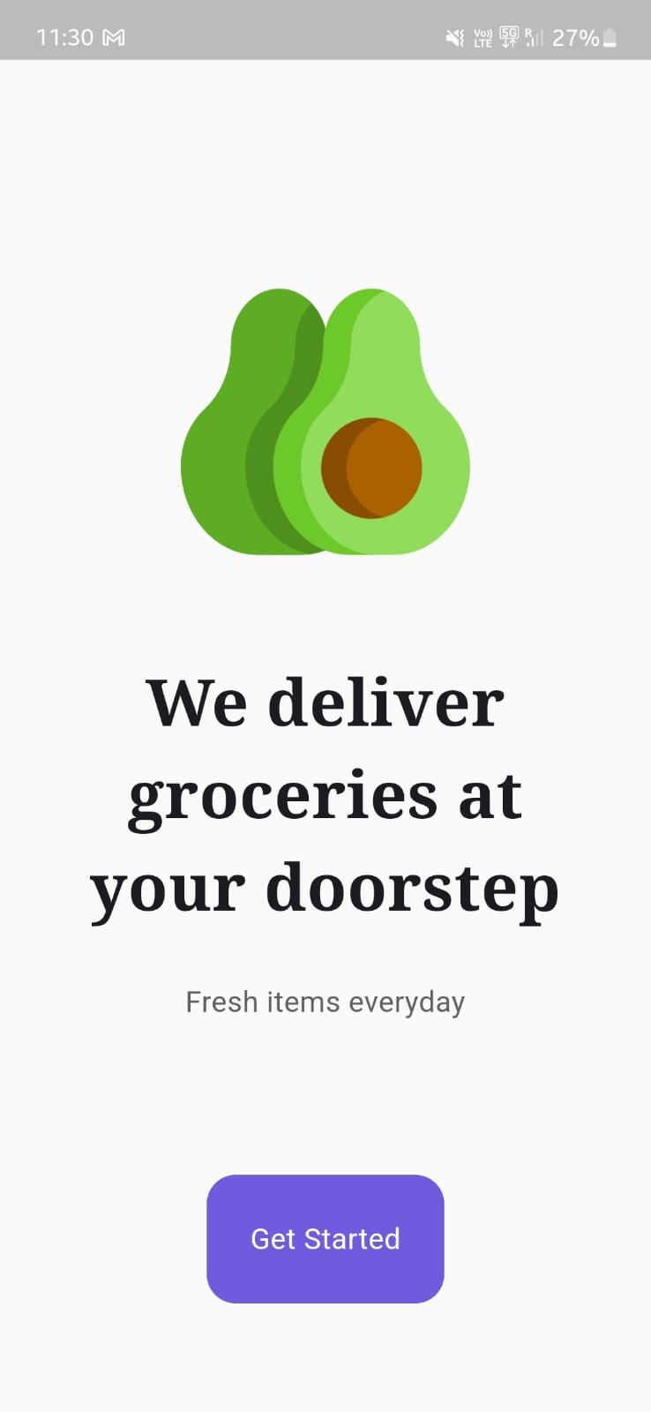 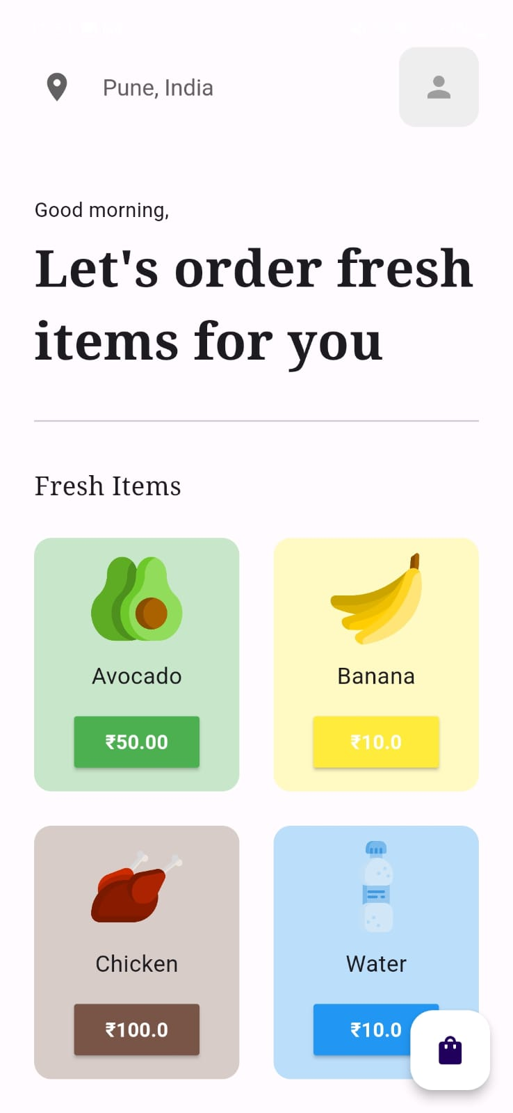

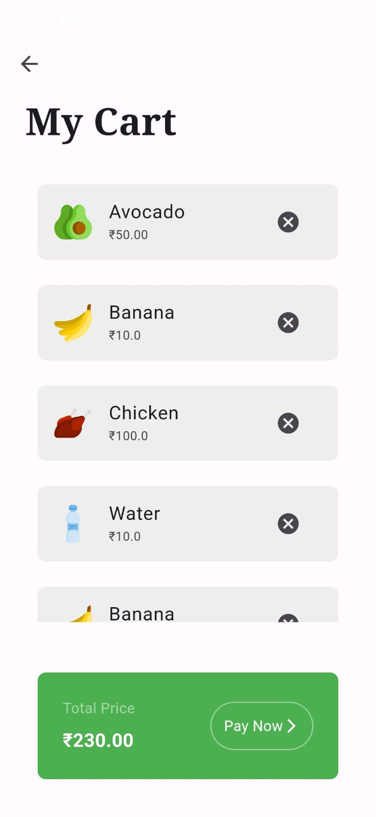 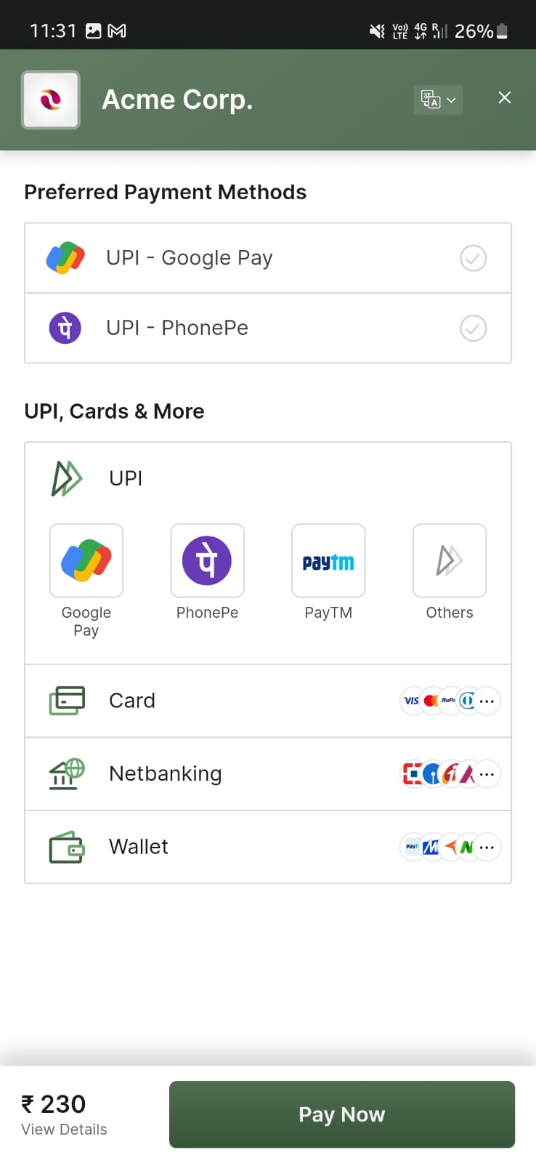

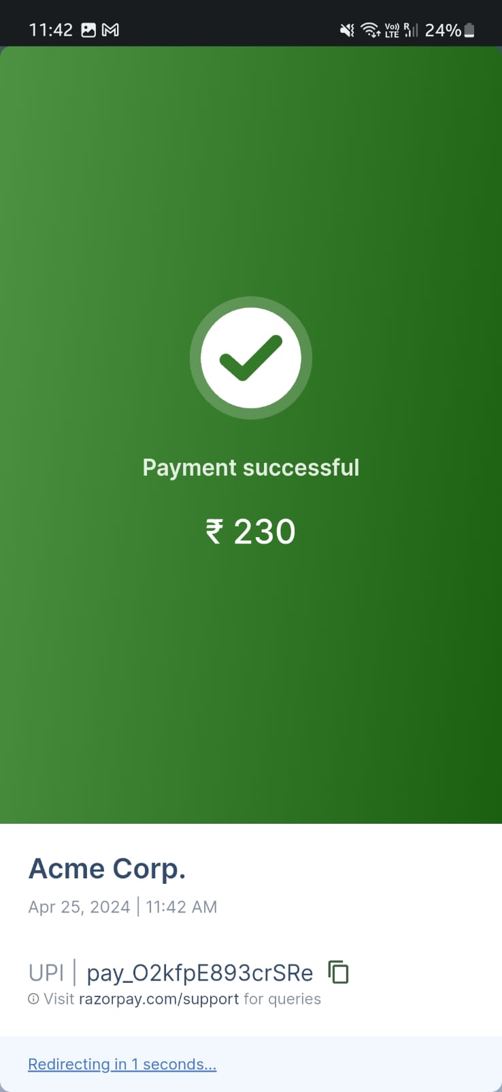

**Future Scope**

The future scope of a Flutter-based grocery app with Razorpay integration is ripe with opportunities for advancement and expansion. Potential areas of development include enhanced personalization through machine learning, augmented reality integration for immersive shopping experiences, voice commerce for hands-free transactions, and subscription services for recurring purchases. Social commerce features, integration with IoT devices, and geolocation-based services can further enhance user engagement and convenience. Additionally, exploring new markets, blockchain integration for supply chain transparency, and a commitment to continuous optimization and innovation are key to staying competitive and meeting evolving user needs. By embracing these opportunities, the app can remain a frontrunner in the digital grocery shopping landscape, delivering value to users and businesses alike.

**Conclusion**

The integration of the Razorpay payment gateway into our Grocery App has been a resounding success, providing our users with a secure, convenient, and seamless checkout experience. By leveraging Razorpay’s powerful features and capabilities, we’ve been able to streamline our payment processing, enhance customer trust, and drive business growth.

**References**